**AREVALO, DIANE ABBY**

**BSIT-II**

**FUNDAMENTALS OF DATABASES – WEEK 3 – ACTIVITY 2**

Supply/perform what is asking in the following statements. Attach or put a screenshot for each number to support your answers.

1. Search for two websites and perform the following CRUD operations:
   1. Create - signup using your personal information

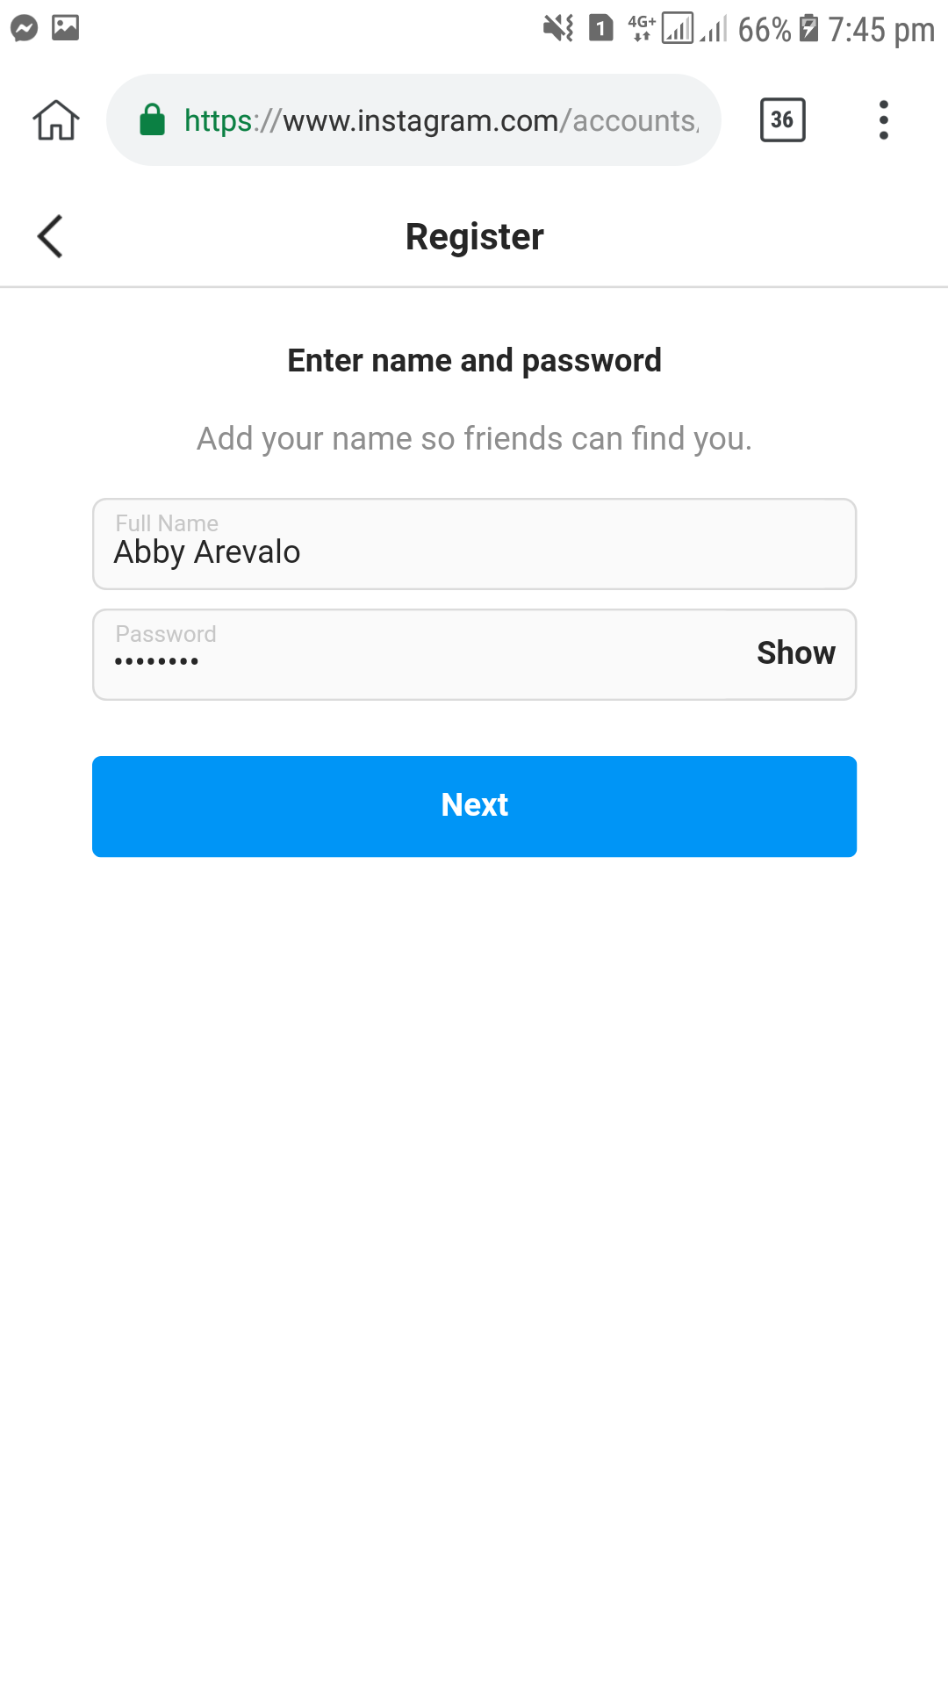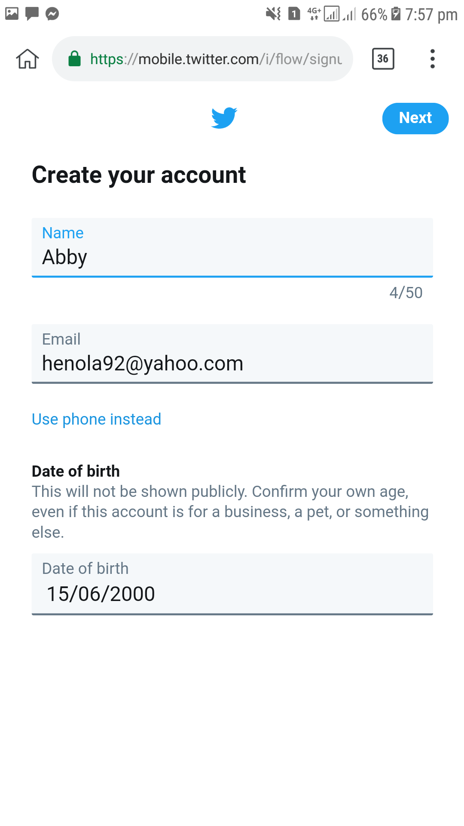

b. Retrieve – search any information to the website

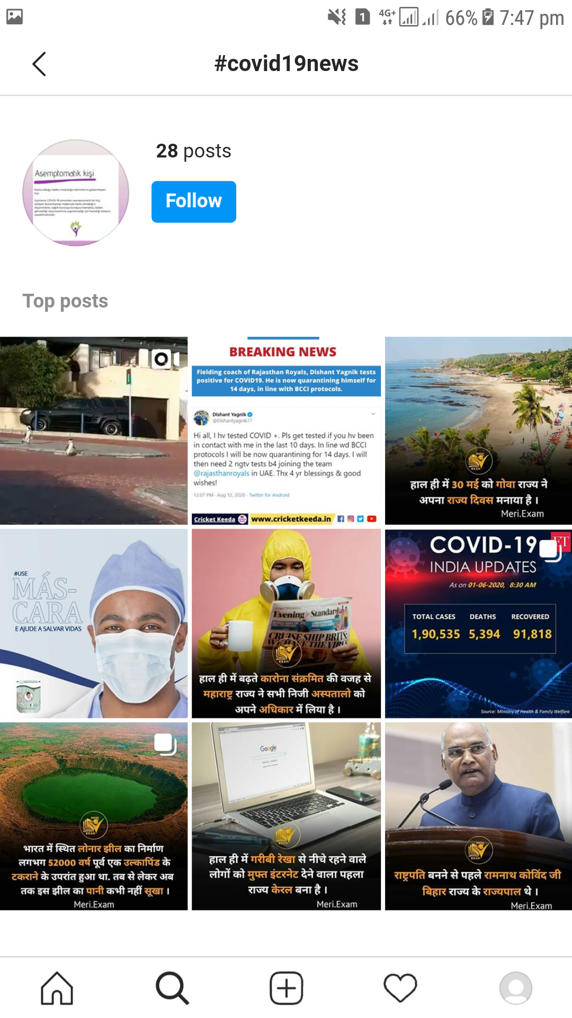

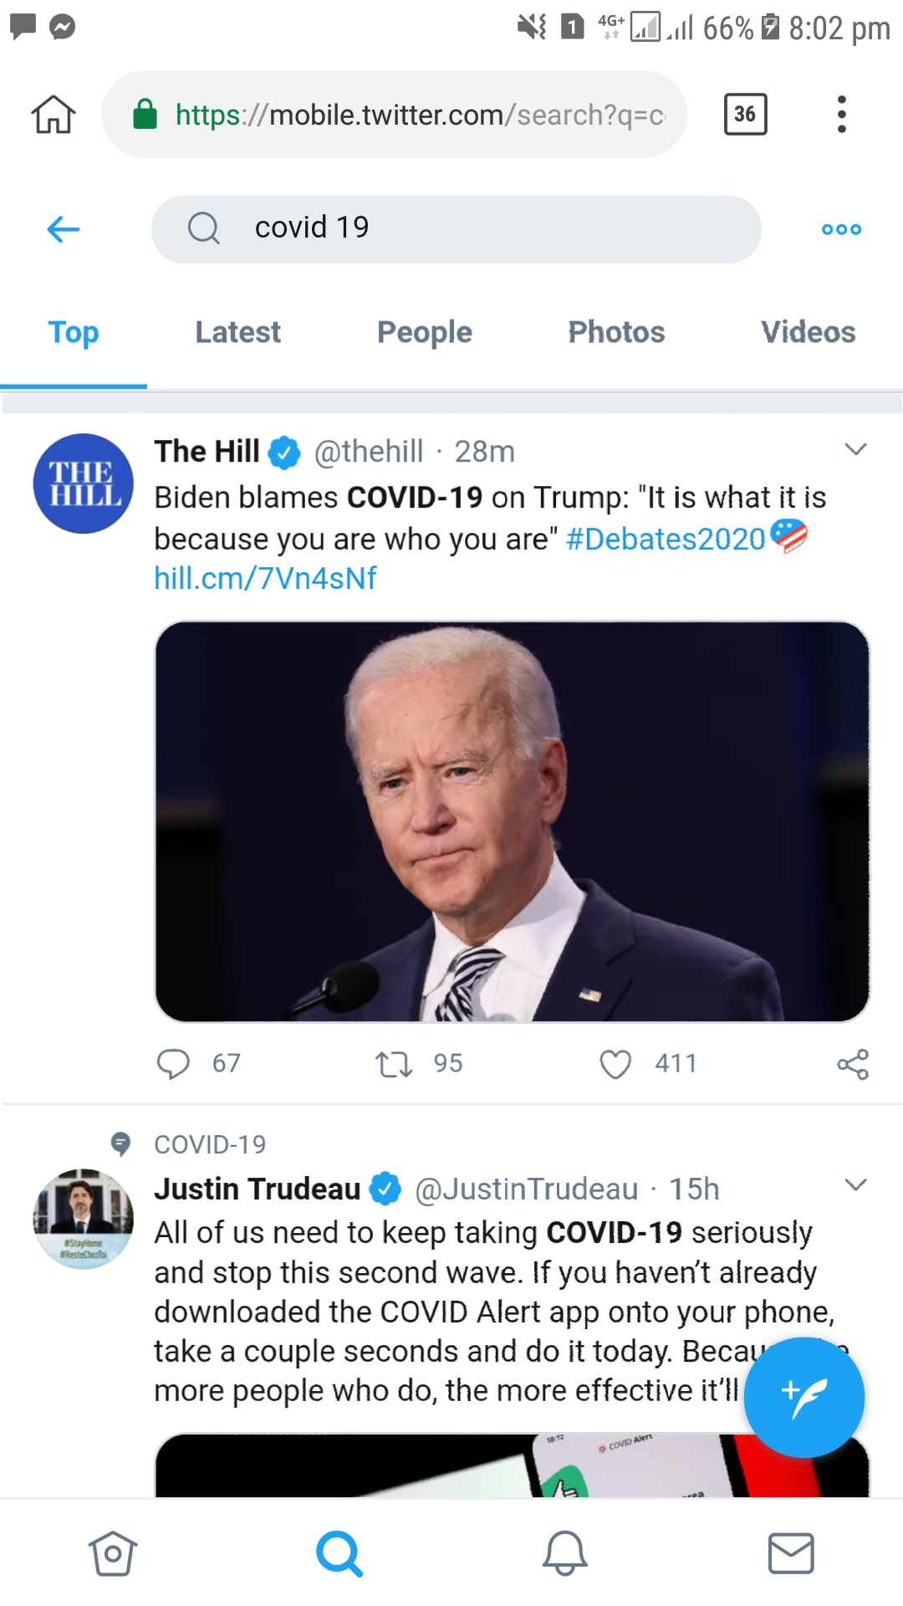

c. Upd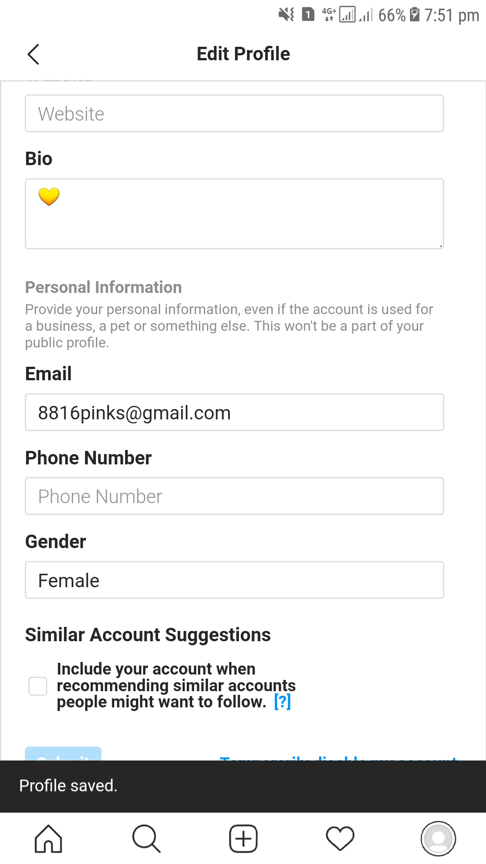ate – update your personal information

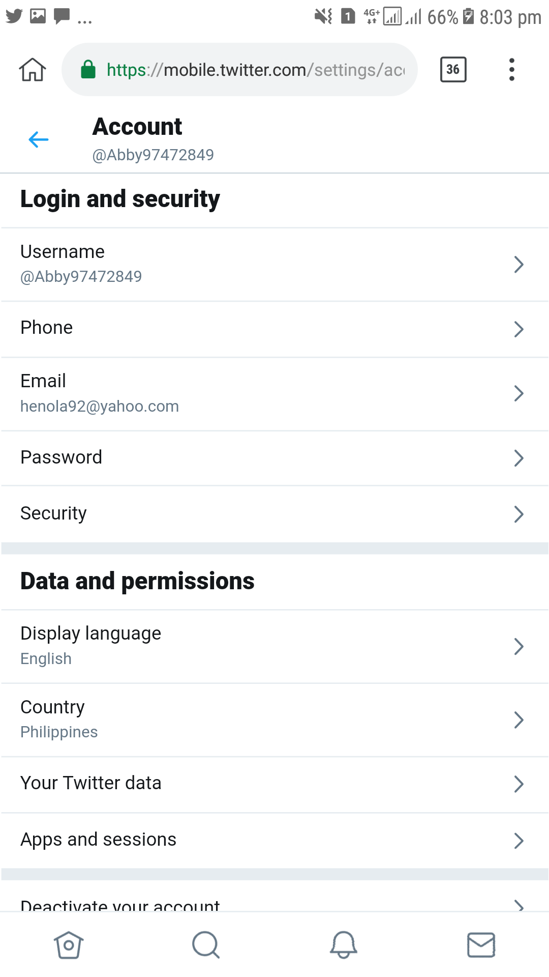

d. Delete – delete or deactivate your account

